AWS IAM User Provisioning, Access Validation, Privilege Escalation, and Remediation Lab

Objective:
The purpose of this assignment is to demonstrate how AWS IAM user provisioning, Role-Based Access Control(RBAC), access validation, test privilege escalation, and remediate inside the aws cloud environment.
Environment:
- AWS IAM
- 3 User Accounts
- 2 Security Groups
- Custom IAM Policy
- Amazon S3
Phase 1: Provisioning:
In this phase of the project, I provisioned user accounts, groups, and policies to simulate the onboarding process within an AWS IAM environment. User accounts were created and assigned to groups based on their job functions, implementing role-based access control (RBAC) principles. Permissions were assigned according to the principle of least privilege, with HR and Network users receiving only the access necessary to perform their responsibilities, while administrative S3 permissions were assigned to the S3 Admins group. A custom IAM policy was then created to introduce a controlled privilege escalation scenario for security testing purposes.

For this lab I began by creating two new user, Todd-Barkley and Caroline.
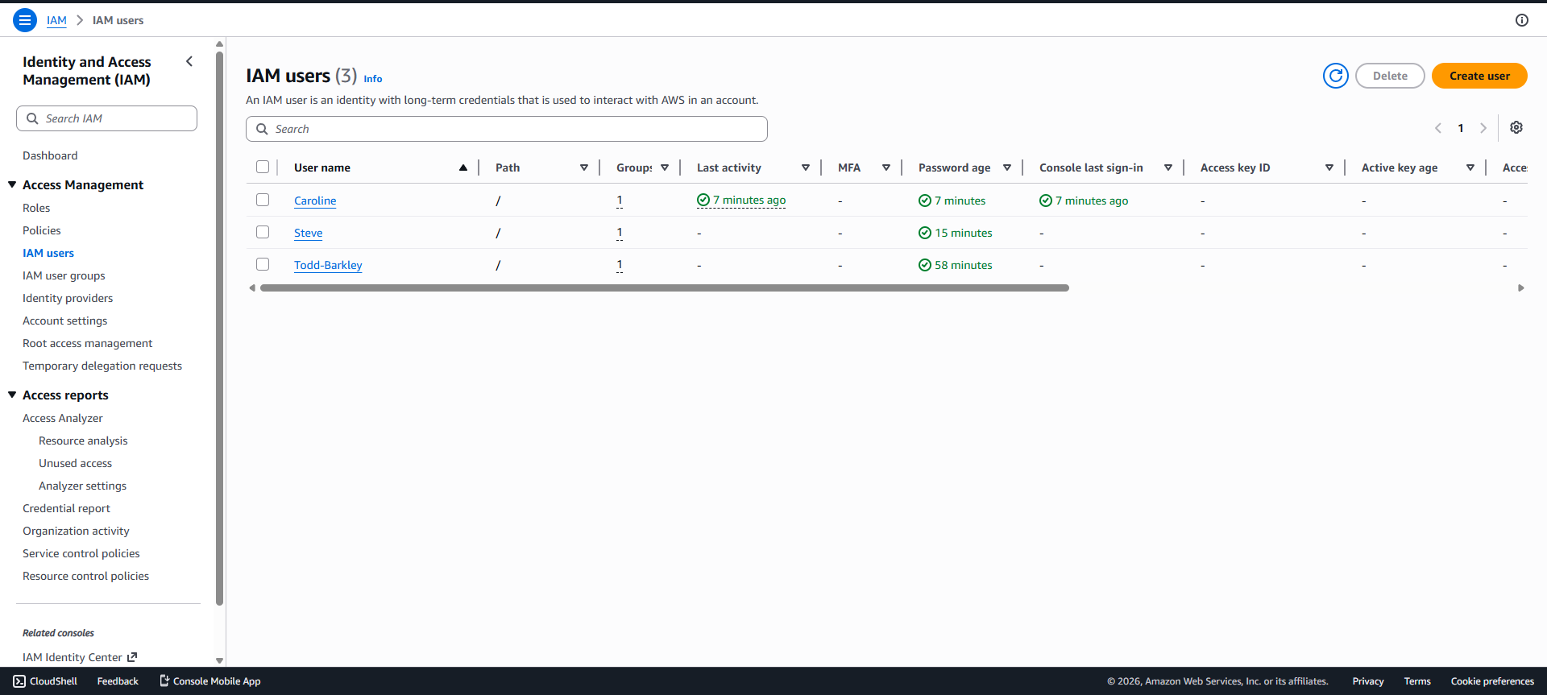

I Then created 2 new user groups and assigned the new users to the user groups to simulate assigning users to a new role that wasn’t predefined before.
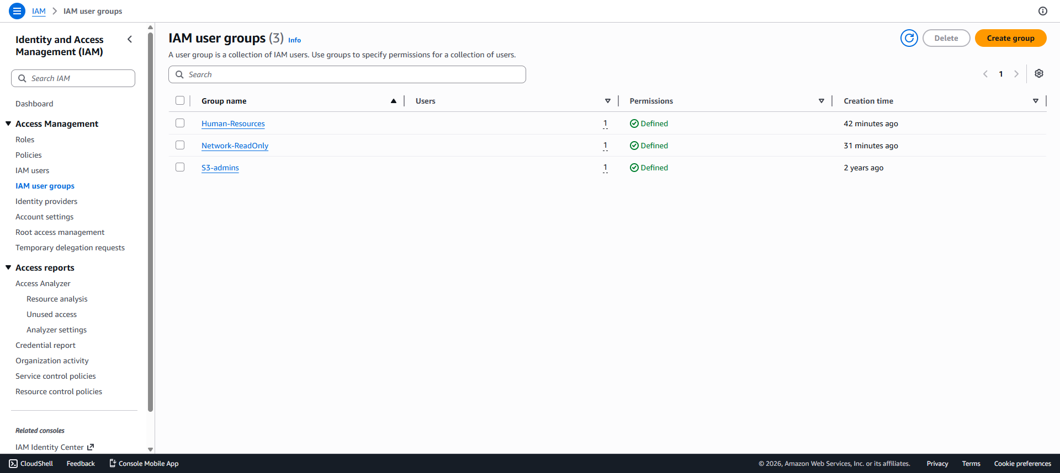

To evaluate the impact of excessive permissions, a custom IAM policy was created and assigned to a test group to simulate a privilege escalation scenario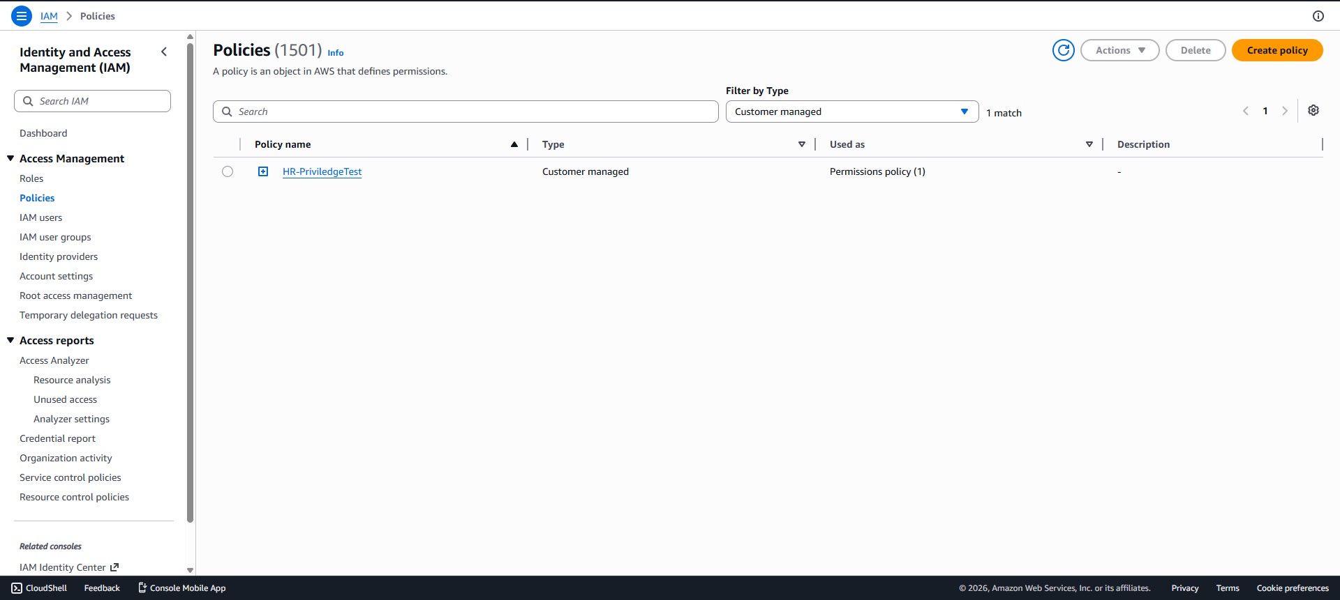

I then added the new policy into the human resources group to give users in this group the ability to assign roles.
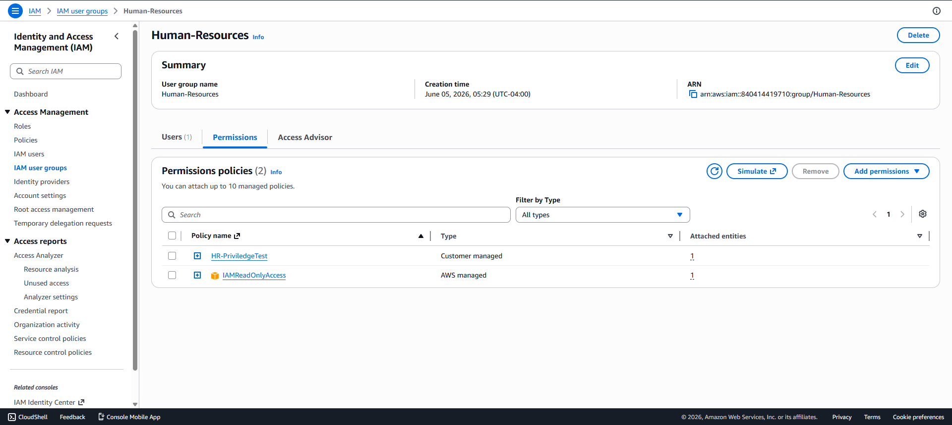

Phase 2: Access Validation & Privilege Escalation.
In this phase, I validated access for each user account and confirmed that the accounts could successfully log in. When logging in to Caroline's account for the first time, AWS prompted a password change, demonstrating a common onboarding security control. After logging in, I reviewed Caroline's permissions within IAM and confirmed that she could view IAM resources but could not create users, groups, or policies. While reviewing the assigned permissions, I discovered that the HR group policy allowed users to add members to groups. To test the impact of this permission, I added Caroline to the S3 Admins group and then verified whether elevated access to Amazon S3 had been inherited.

User account validation
Caroline:
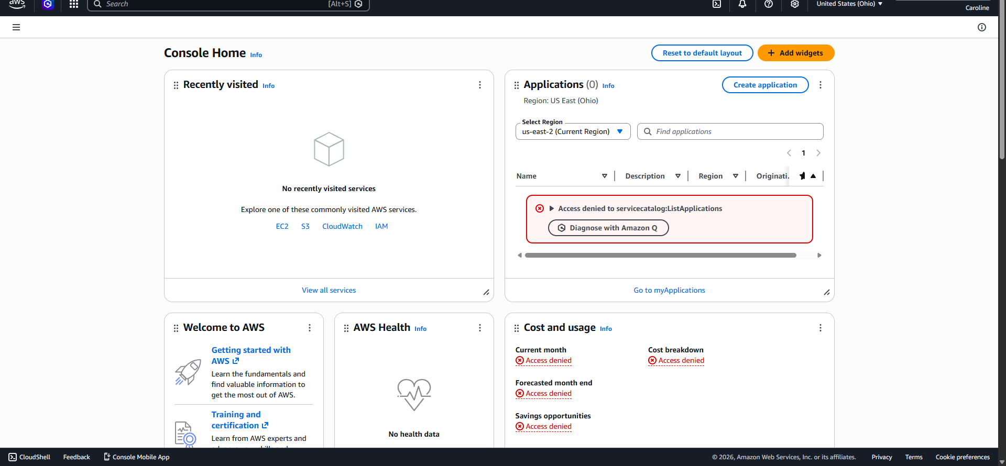

Todd-Barkley:
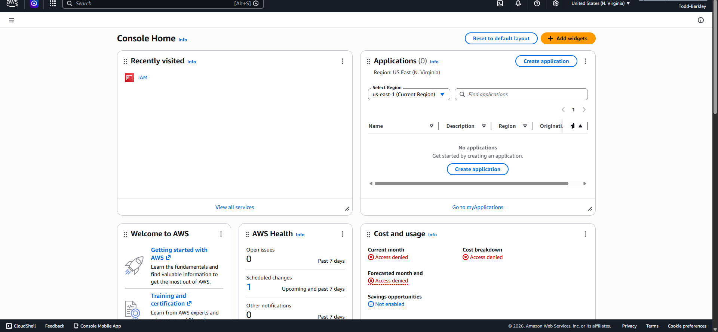

Steve: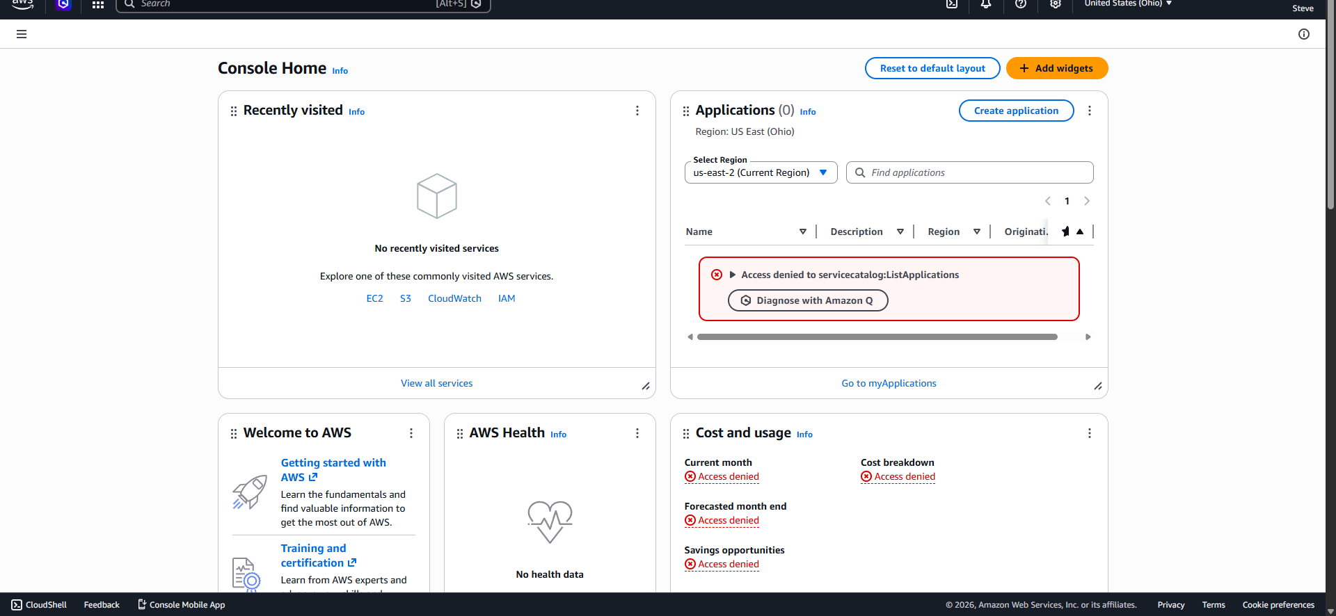

Caroline’s s3 bucket provisioning.
s3admin group.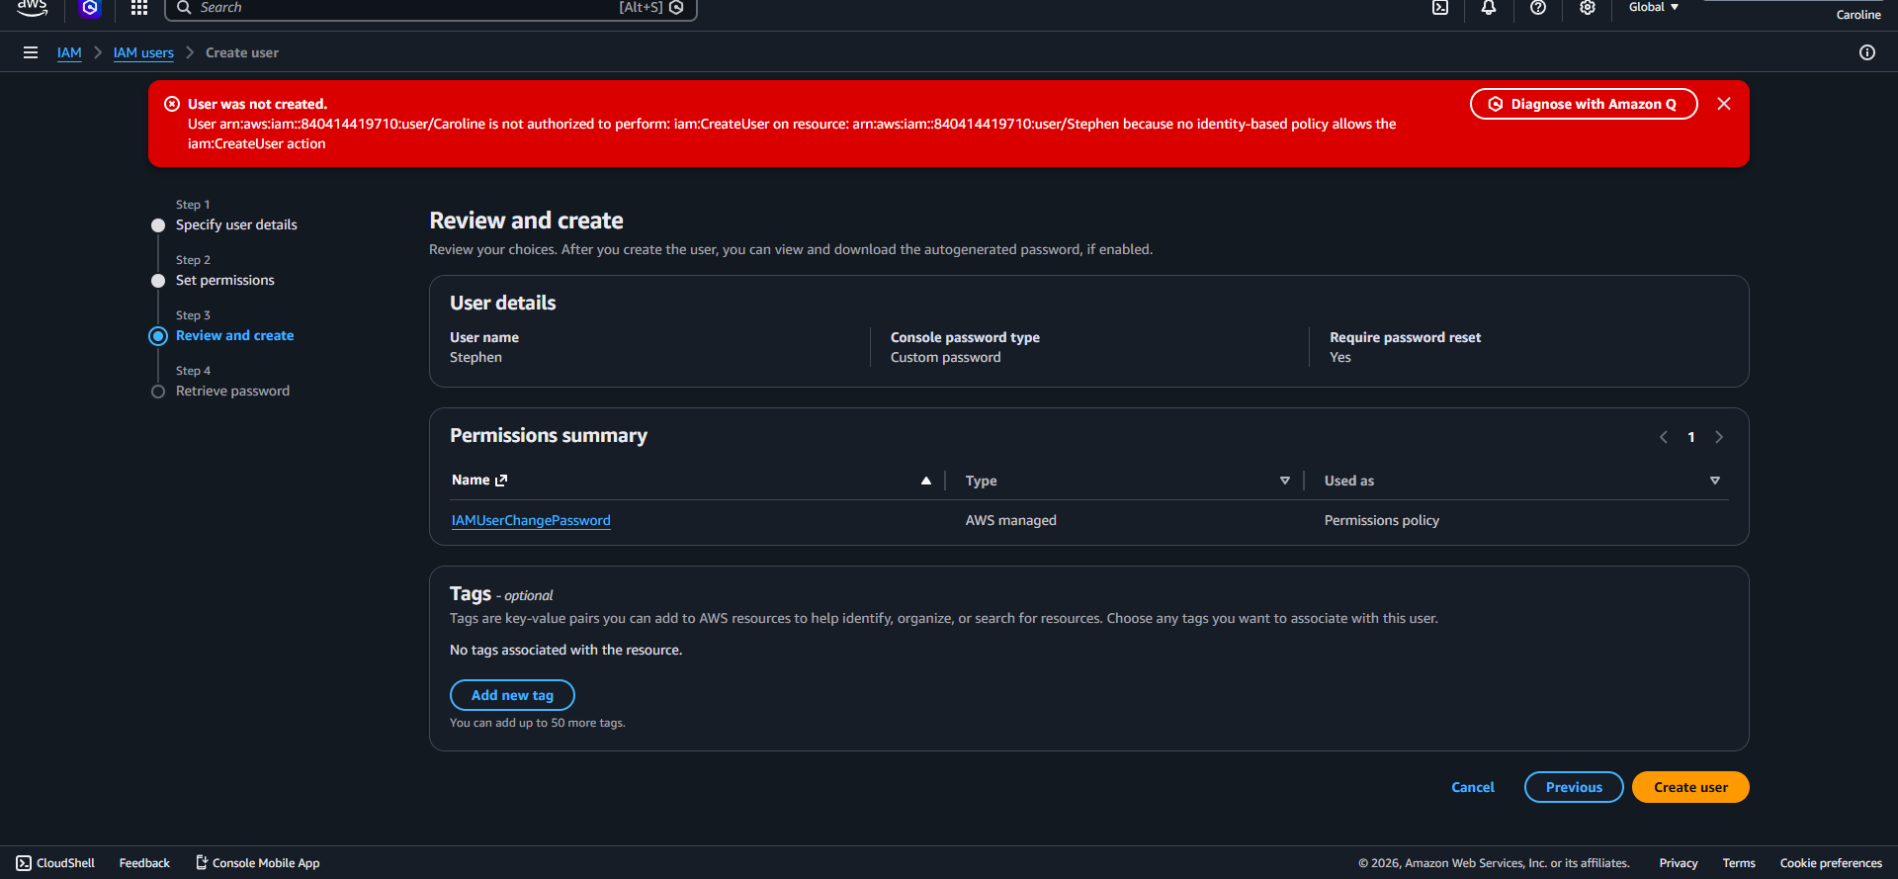
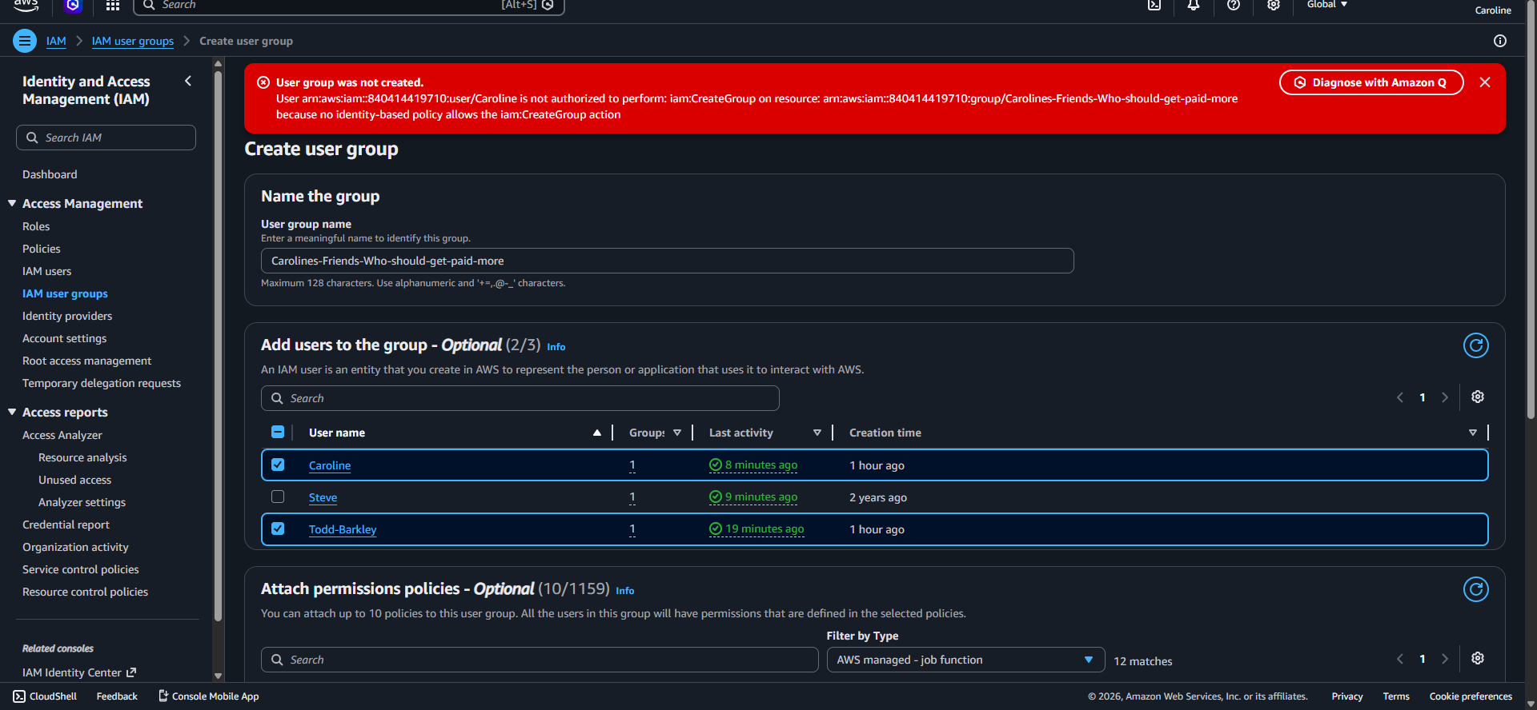
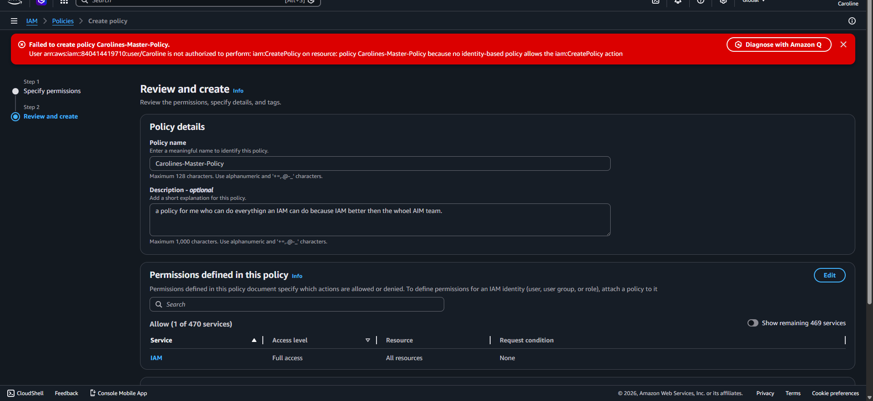
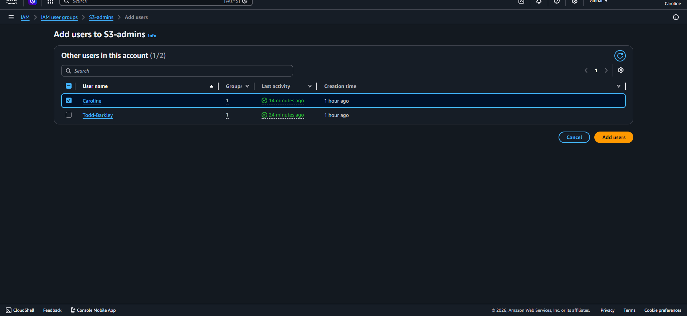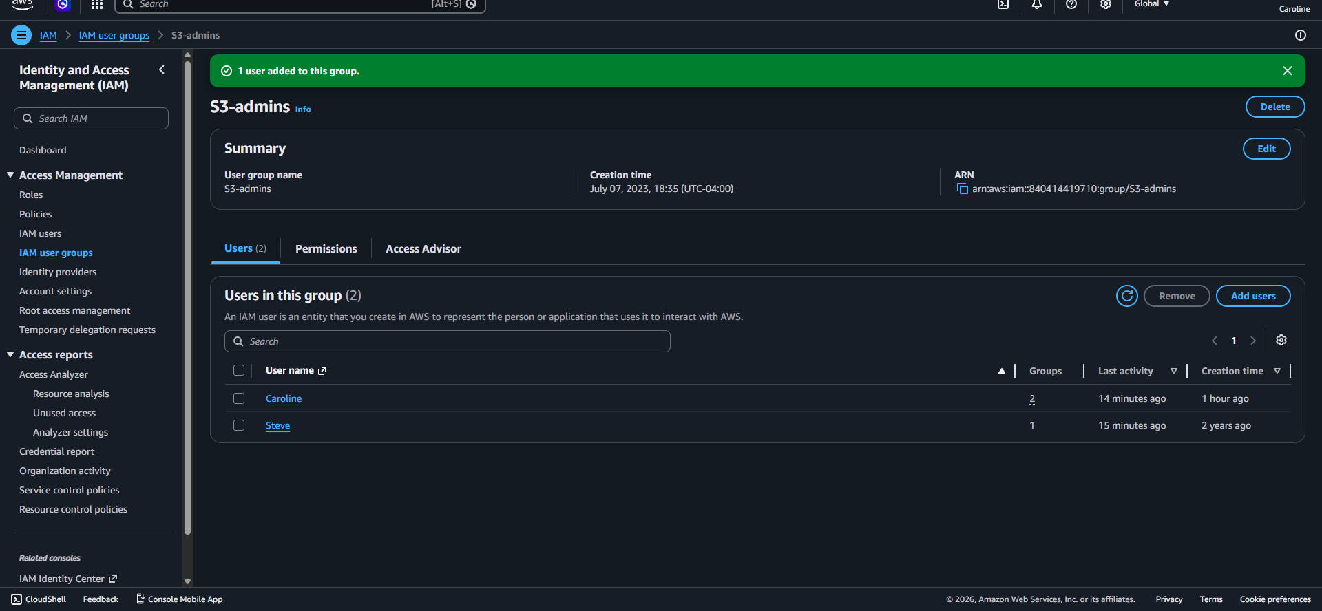

Following successful privilege escalation, access to Amazon S3 was validated to determine the operational impact of the newly acquired permissions. Caroline was able to view the premade s3 bucket but also created their own bucket(folders) and add objects(files) to the buckets.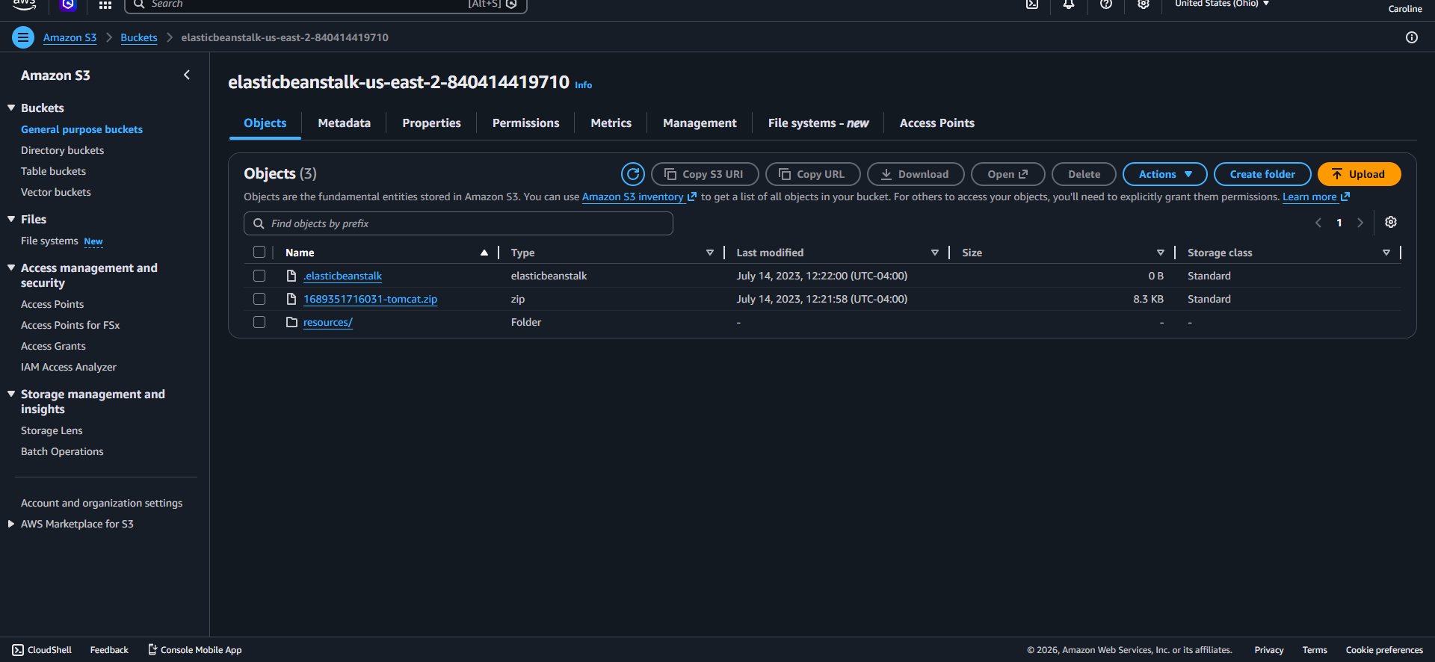
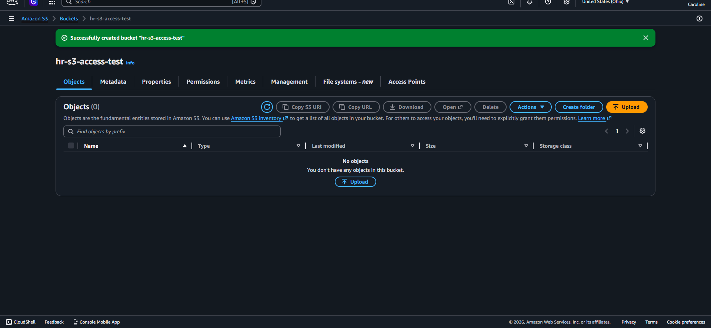
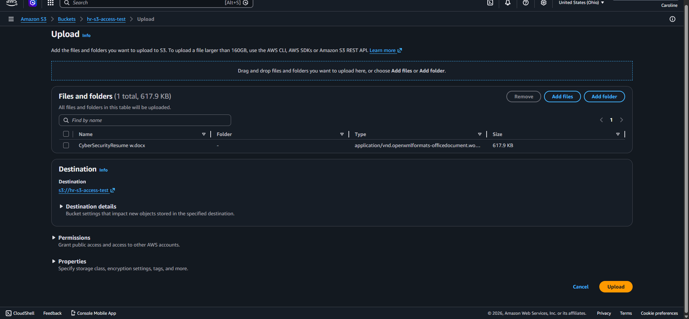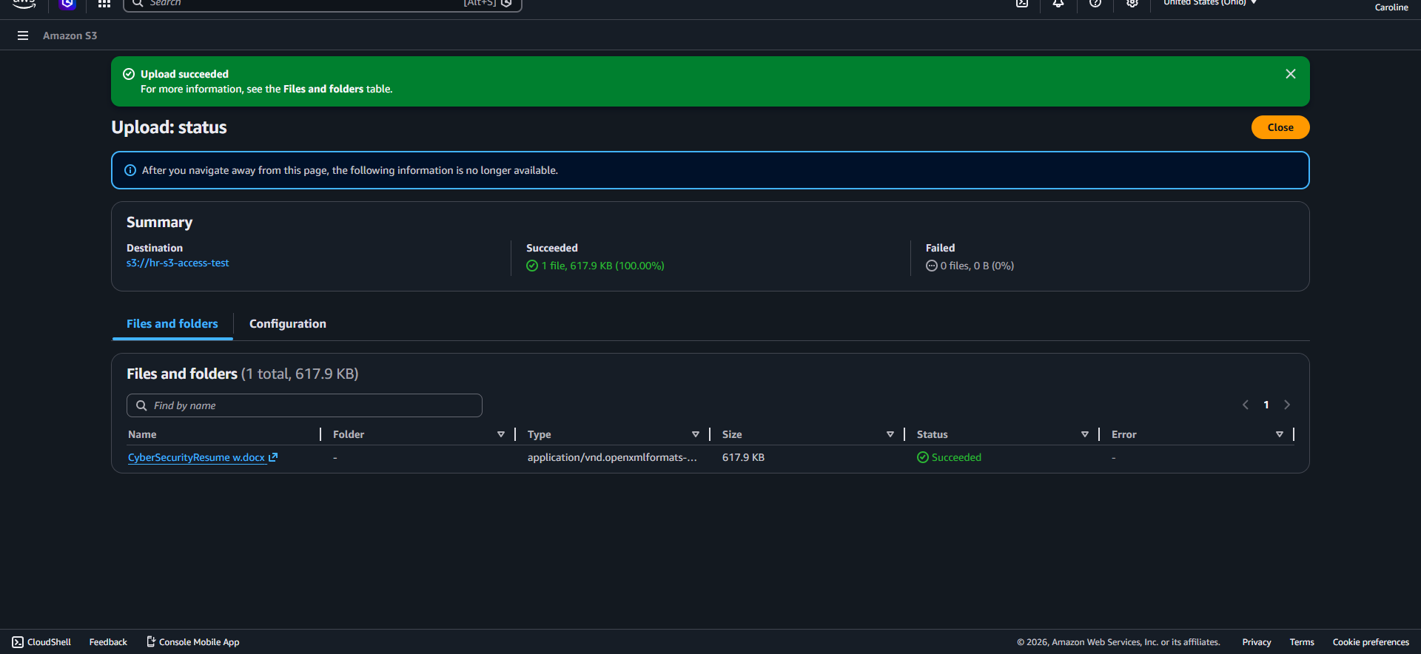

Phase3: Remediation
In the remediation phase I removed the test objective from the s3 bucket and then deleted the bucket. After cleaning up the created resources, I removed Caroline formt he S3admin group to revoke the elevated permissions. I then removed the custon IAM policy from the human resource group and deleted the policy entirely to restore the path of least privilege and prevent further unauthorized privilege escalation.

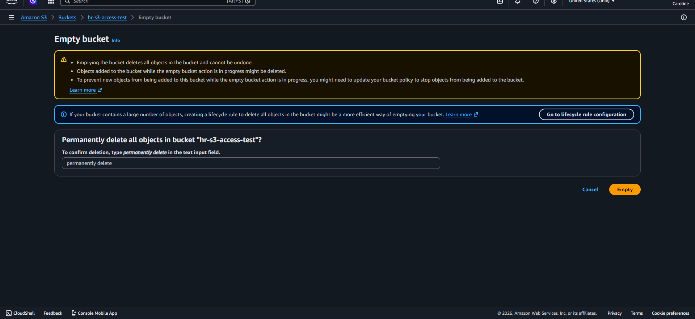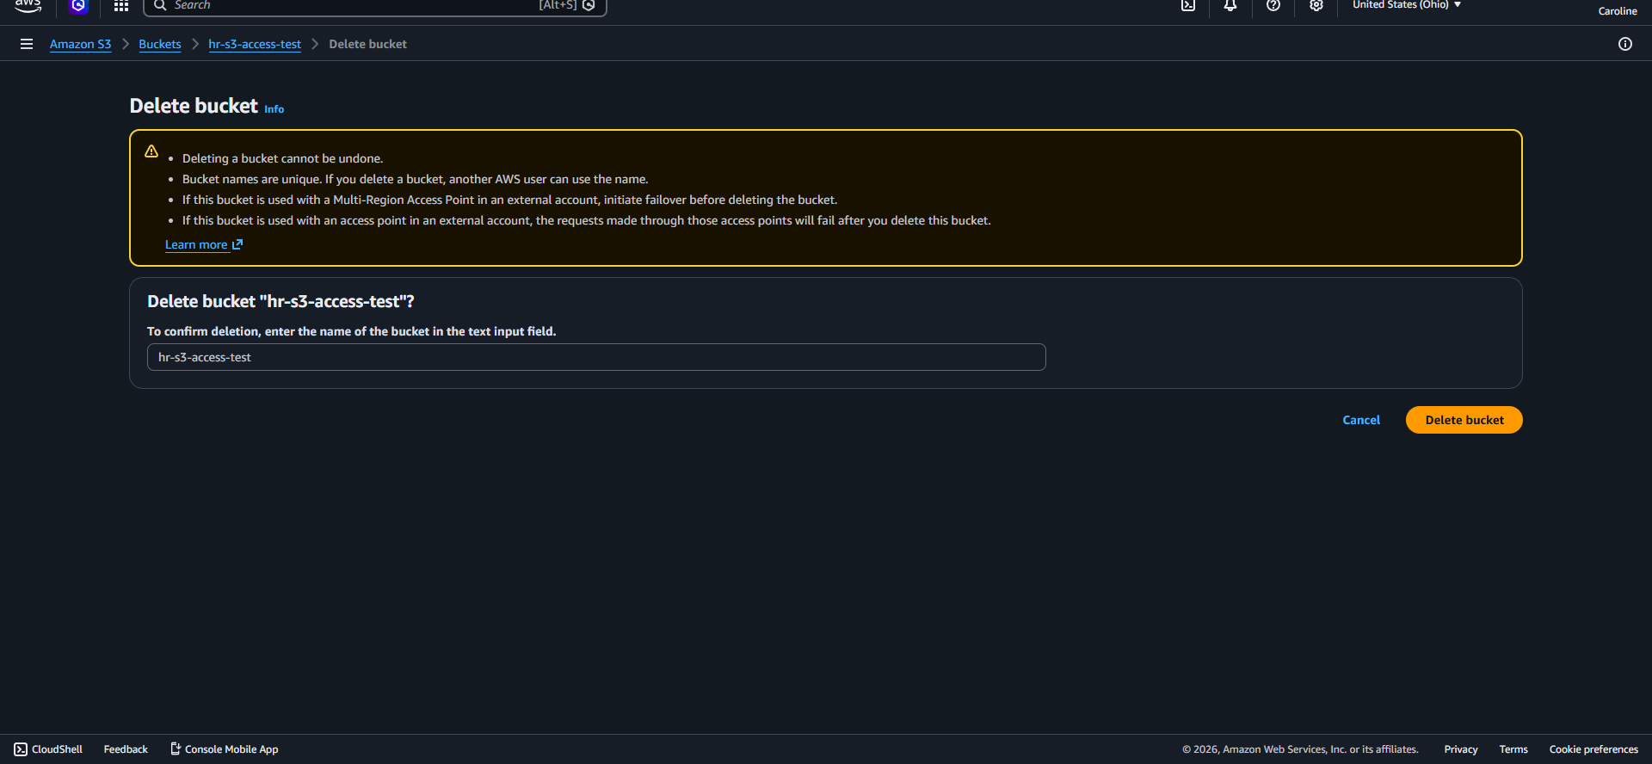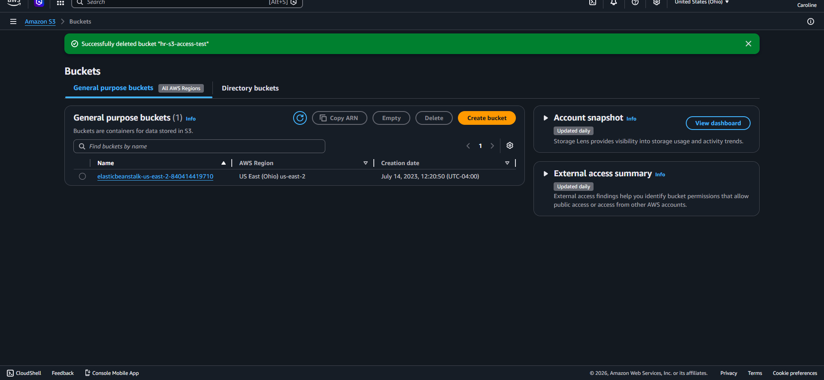

After deleting the bucket I switched back to the root user account to investigate what 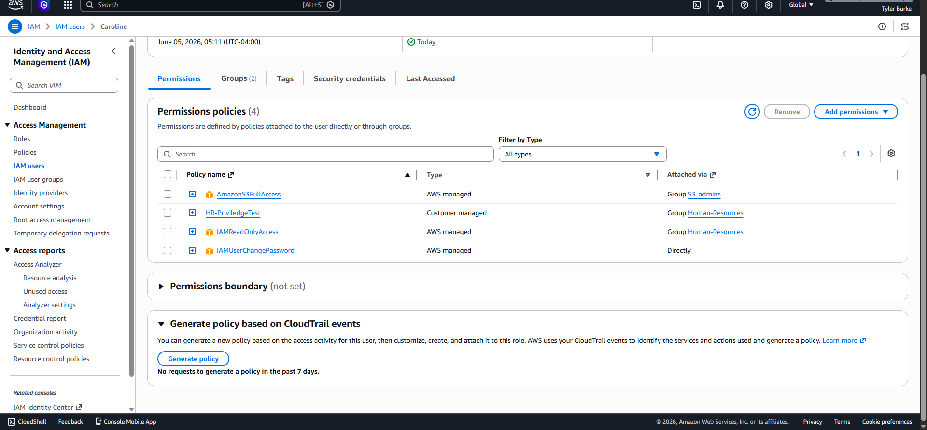
I see that she has 4 permissions now, 1 being s3admin which I romeved from her account, however one of the hr policies seemed interesting so I investigated further.
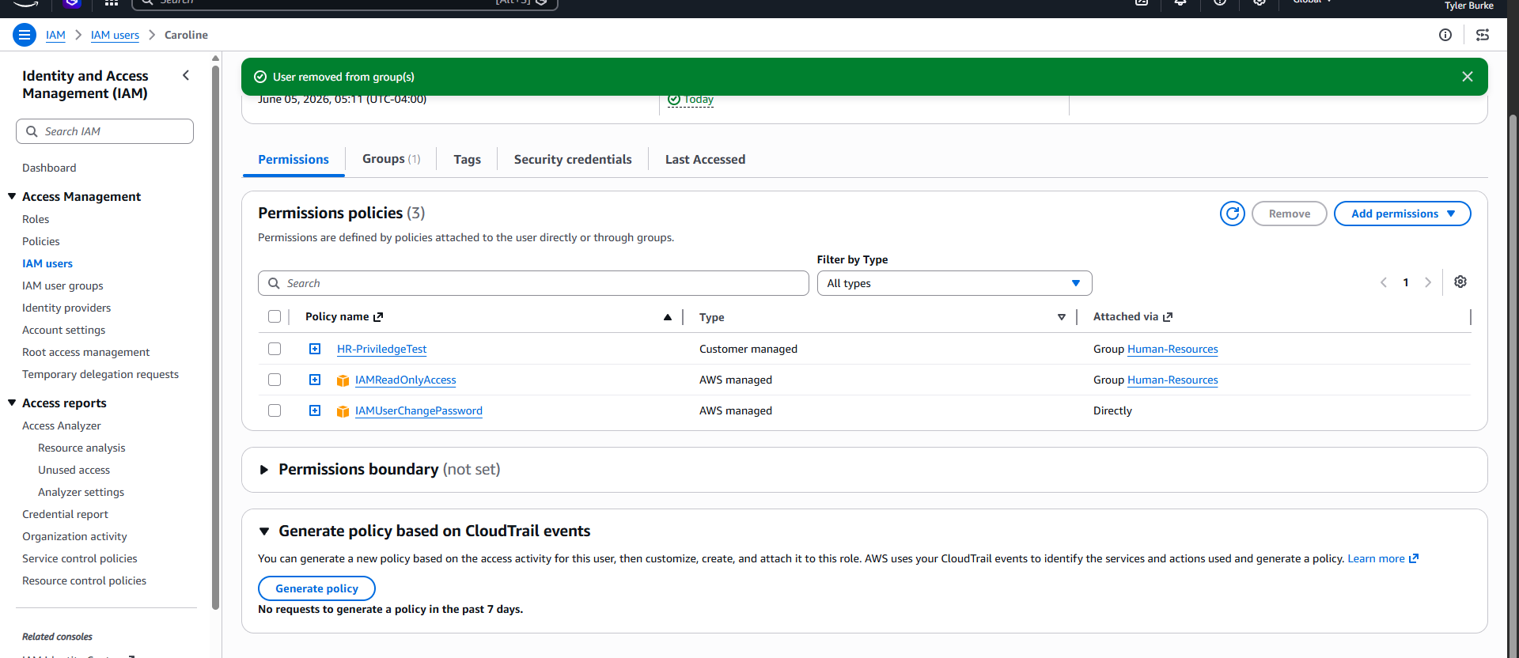

In the Human-Resource group I found that the one policy shouldn’t be there as this allows users to elevate their privilege, I then removed that policy from the user group to sanitize and make sure no other human-resource employees can privilege creep. 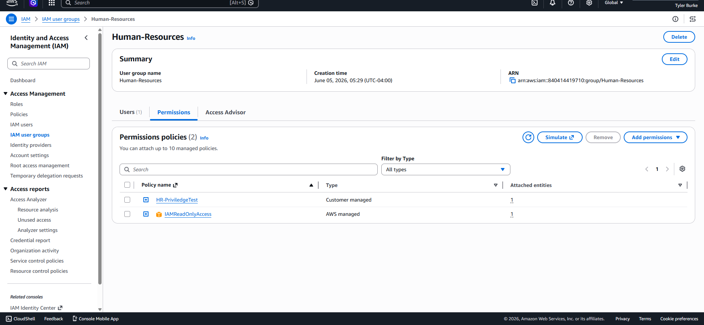
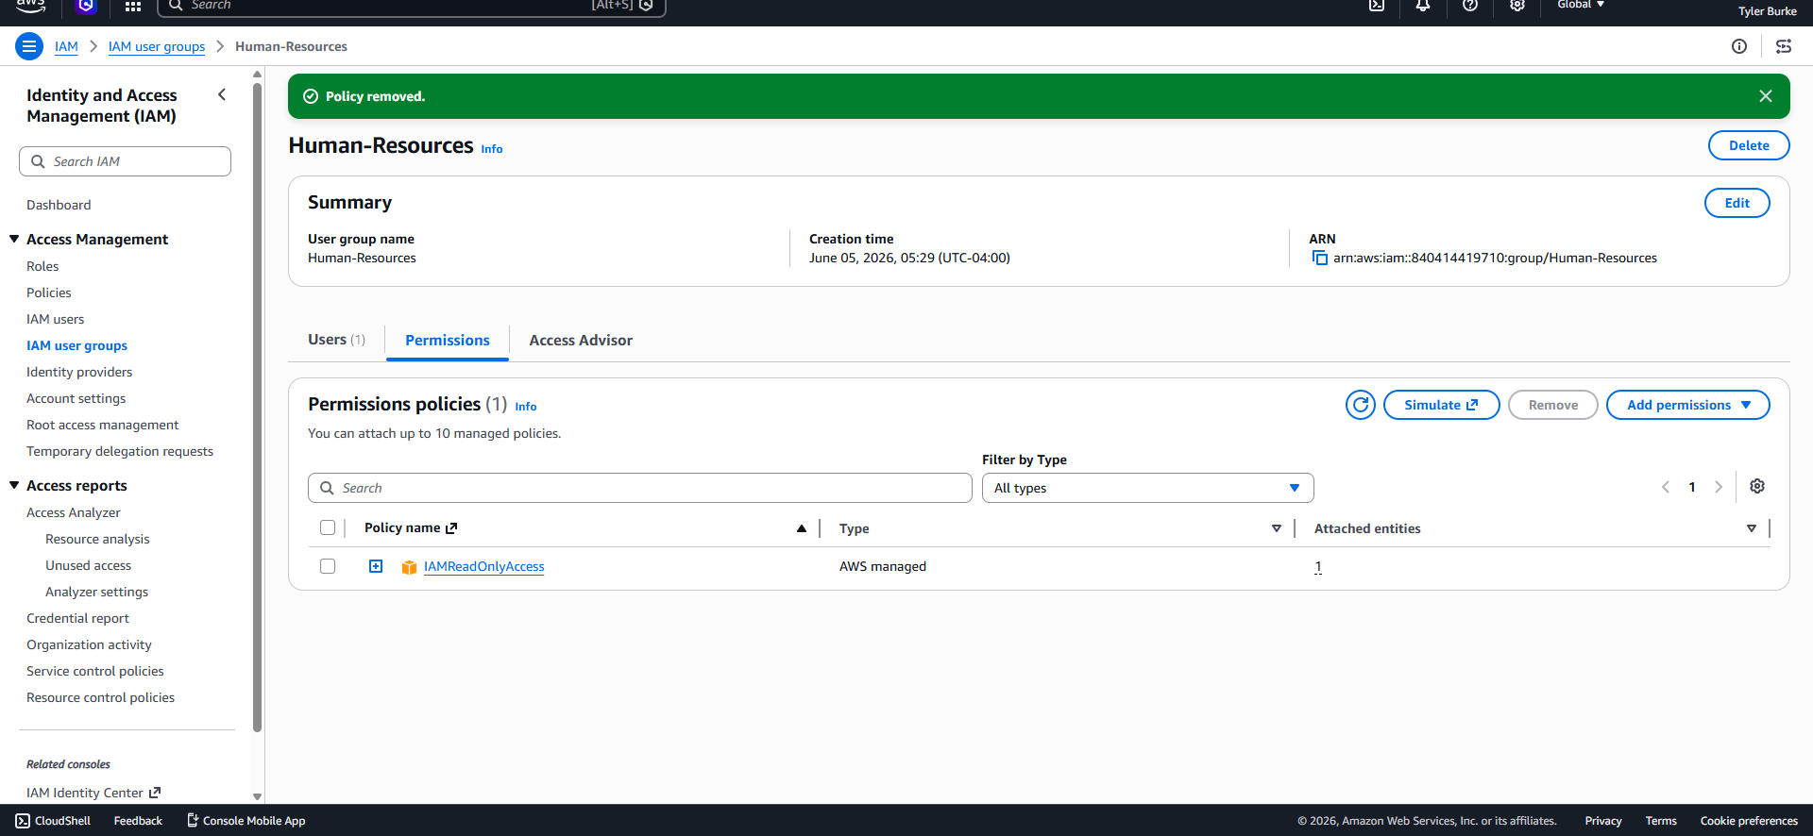

I then entered the policies tab to delete the privilege escalation policy. 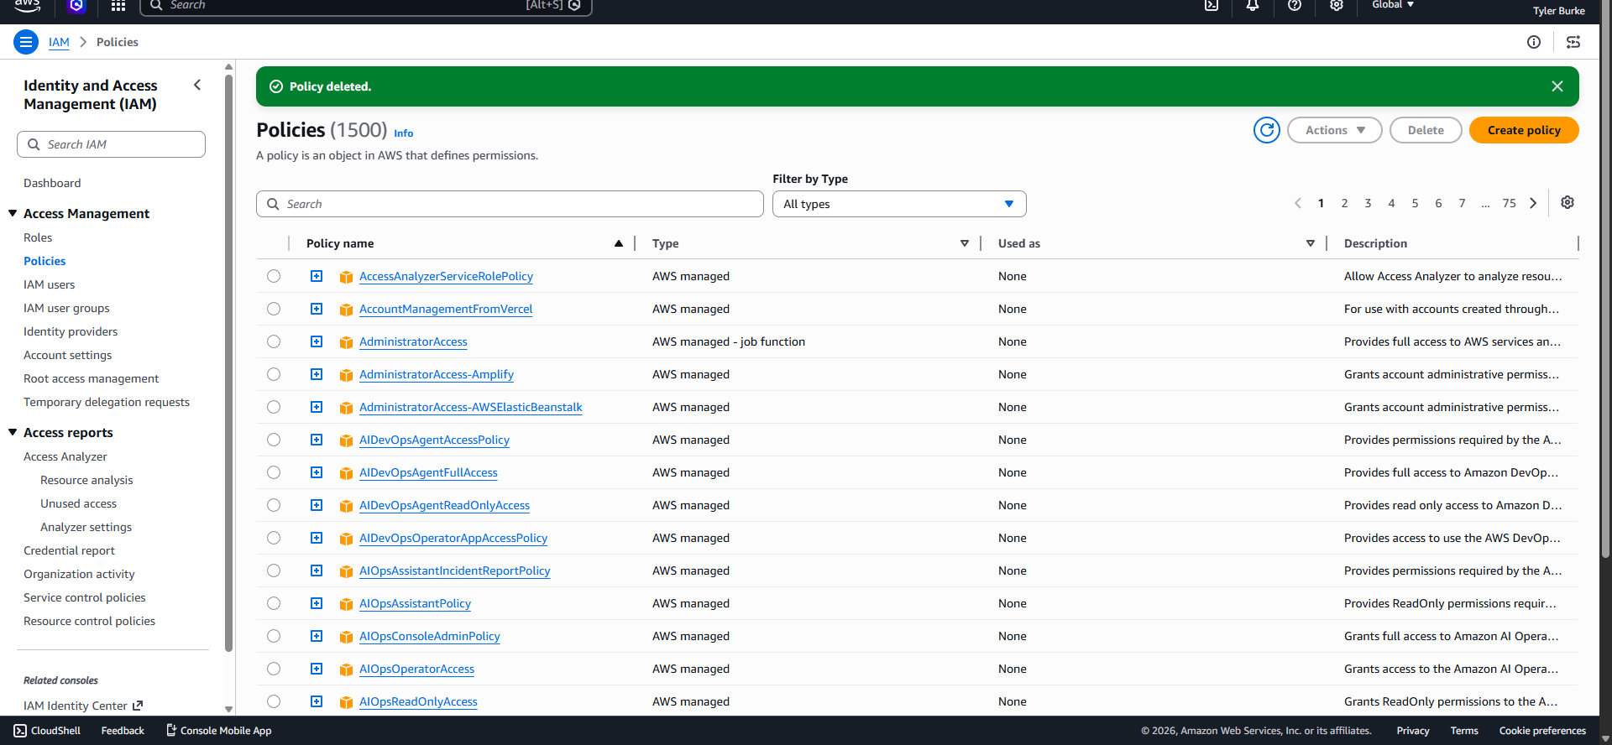
Lessons Learned:
This project reinforced the importance of Role-Based Access Control (RBAC) and the principle of least privilege within an AWS IAM environment. While Caroline was unable to create new users, groups, or policies, she was able to escalate her privileges by adding herself to the S3 Admins group through a misconfigured permission. This demonstrated how a single excessive permission can lead to significantly expanded access and increased risk to cloud resources.
Through the remediation phase, I gained experience identifying the source of excessive permissions, removing unauthorized access, and restoring intended security controls. The project also highlighted the importance of regular access reviews and policy audits to prevent privilege creep and maintain a secure IAM environment.

